Bible Study – God in Emily’s Story, God in Our Stories
(based on the novel Sticks and Stones)

Chapter 1
Study Theme for Chapter:
- When your world is turned upside down, where is God?

We see Emily’s life turned upside down from the very start of this novel with police pounding on the door to arrest Emily’s mom. Then we experience the emotion of this upheaval. On page 8-9, we read:

Jared’s chest heaved up and down like he’d been running, his mouth quivered. “Yeah, whatever, I’ve heard that line before. Us kids aren’t allowed to know anything, but we still have to live with all your problems.”
“I love you guys. You’re the best, okay? Please remember I love you and um, know that I’m sorry.” Tears showered her face.
I hated seeing her helpless, unable to even wipe her tears because of her cuffed hands, or to make things better for us like she always did. I knew this couldn’t be her fault. My mom was a good mother. She worked long hours as an emergency room nurse. We lived in a nice home, in a quiet neighborhood, in beautiful Southern California. Things like this didn’t happen to families like ours. “Why are you letting them take you? Where’s Richard? Why aren’t you fighting back?”
She looked down at her feet, opened her mouth like she wanted to say something, but nothing came out. I ran to her, wrapped my arms around her waist. I breathed in her scent, a mix of her bath soap and vanilla perfume, felt a tear fall on my arm. I put my finger on that tear and let it soak into my skin where it would stay with me.
When the police officer pulled Mom away, I tried to hang on. I clung to her as long as I could, until they wrenched her out of my arms. Jared still stood there with his arms hanging down, his hands clenched tight into fists that might flail and punch if one more thing triggered them. The police officer led Mom out of my room.
I wanted to run down the hallway and pull her back, scream and tell the police they’d made a big mistake. I stared at all the things in my room that had her touch on them, the stuffed animals she bought me, the comforter of bright pink and green she bought when we redid my room, the pair of Reef flip flops I borrowed because we now wore the same shoe size. I wanted to hold it all close so no one could take any of it from me. I slipped on the flip flops, grabbed the white, plush lamb that felt like her coat. I felt like a four-year-old who lost her mom in the store. I held the lamb and the tears would not stop.

Questions for journaling/discussion:

- Can you remember a time when life felt out of control, when the person, thing, or situation you counted on was no longer available?
- What emotions do you recall having at that time? Anger like Jared? Extreme sadness and shock like Emily?
- Did you have anything that comforted you during this time, or contrastingly, anything that made the loss more difficult?

Emily tried to keep her mom’s tear, then her mom, finally a stuffed lamb. None of these things made her feel better. She did, however, still have Jared. On page 10:

“Even though he was only sixteen, he was strong, and present, and honest, and real. I didn’t have a dad to turn to. He’d disappeared from our lives when I was a baby. Thank God I had Jared.”

God has been present this entire time, but this is where Emily first sees it, through Jared. God often gives us other people to show his love for us during loss and difficulty.

- Who has been present for you during a hard time? What did they do that helped you?
- Is there anyone who might need your presence?
- Who can you lift up in prayer for God’s presence and comfort?
- What comfort do you need right now? Ask God for his presence and peace in this.

Understandably, Emily has a little bit of difficulty when trying to choose what to take with her to her grandmother’s house. On page 11:

“But even though I hoped for a short stay, I had a bad feeling it could be longer. I couldn’t stand to leave some things behind, just in case.”

After describing numerous items that she treasures and doesn’t want to leave behind, she sees her Bible.

“The last thing I saw, staring at me from my desk, was my Bible, another gift from Mom. I touched its black leather edges, ran my fingers along the engraved lettering. I didn’t want to pick it up. Unlike the words in my journals, I didn’t know if I could trust these words. Maybe all those times of reading God, I could have been reading more J.K. Rowling, more S.E. Hinton, more John Green. Why had God left me without parents, left me with a sprained ankle right before Track season, left me alone? I decided the Bible didn’t need to come with me.”

That one was tough to write. As the author, I really want her to take that Bible with her. I want that to be the thing she grabs without a doubt. But I know that in life, our faith can waiver. Sometimes we’re angry, and unfortunately, that anger can cause us to pull away from God, doubting that he is there for us.

At the end of Chapter One, Emily sees her grandmother’s car and says:

“I blew the pink flower off my hand, watched it float and land, wished I could float away too.”

And there we have that very relatable feeling in difficult times – the desire to escape from it all. But most of the time, as with Emily, escape is not an option. Emily is feeling alone, and she is unable to escape from the pain she feels at this moment in her story.

So what is the solution to feelings like Emily has, the same feelings we might have now or at some moment in the past, and where is God in this moment? Where is he for us?

The truth is, God is with her, and he is with us. He is there even when we don’t feel it, even when we are angry, frustrated, sad, doubtful, unfaithful, or any other describer you want to add to this list.

Key Verse Focus

If we are to follow where God is in Emily’s story right now, then perhaps we would read Deuteronomy 31:8. This is one of many verses that promise God’s presence, but for now, let’s focus on this one.

Deuteronomy 31:8 says,

“The Lord himself goes before you and will be with you; he will never leave you nor forsake you. Do not be afraid; do not be discouraged.”

Try this:

- In a journal, copy Deuteronomy 31:8.
- Read it again.
- Underline or highlight what this verse says the Lord does.
- Underline or highlight what this verse says God will never do.
- Circle what God asks us NOT to do.
- Complete this version of Deuteronomy 31:8 using the verse above or from your own Bible.

The Lord himself _______ ________ me, will _____ ________ me, will never ___________ me, and will never ______________ me.
He reminds me to not ____ ___________ , and to not ____ ______________.

- Now rewrite this in your journal or somewhere you will see it often.

During difficult times, it’s easy to allow our minds to focus on the negative, the things we don’t have, the things that are bringing us down. Notice in this chapter of Sticks and Stones that Emily says “Thank God I have Jared.” In this moment, Emily feels a bit of stability and comfort in someone who is there for her when everything else seems to be falling away.

James 1:17 shows us that God is in every good thing, and that his presence is always guaranteed. The verse says:

“Every good and perfect gift is from above, coming down from the Father of the heavenly lights, who does not change like shifting shadows.”

Jared is one of those good things for Emily, and so is the fact that in spite of all this unexpected change and disruption in Emily’s life, God does not change. He is our constant. What we often need in times of uncertainty is not more of the world’s certainty, not more perfect days, but more of the one who is certain and is perfect.

Closing Prayer and Journal Activities:

- Prayer: Say or write a prayer to God. Be yourself and simply talk to him. You never need to hold back your true thoughts and feelings, and you never need fancy words or specific structures to follow. Here are some ideas to get you started if it’s helpful, but remember that the most important part of prayer is simply doing it.

- Thank him for his presence.
- Tell him what is on your heart, what you’re afraid or discouraged about. You can ask him to remind you of his presence and to help you not be fearful or discouraged.
- Pray these things for someone else as well.
- Thank him for people in your life who have helped you in a difficult time.

- Ask him to guide you in helping others, in showing his love for them and being present for them.

- Write: Find an item in your house that is special to you and free write about it, which simply means to write without thinking. Describe it in detail – its colors, shape, texture, how it feels in your hands. What is the story behind this item? How did you get it? Did someone give it to you? Did you find it somewhere? How does it make you feel? Why? Just write whatever you want for 3 to 5 minutes. Writing can be very meditative and freeing if you aren’t feeling inhibited or worried about anyone judging it. No one is reading this but you, unless you decide you want to share it with someone. If you want, you can write a prayer of thanks for this item also.

- Draw: Sketch an item that is meaningful to you, or just draw any simple picture. I am not an artist, but something about drawing and/or coloring is very meditative and uplifting. Right before I wrote this I drew a simple picture of 3 smiling hearts with green stems, sort of like flower hearts. Then I wrote a message on it and gave it to my daughter. There’s something about getting a picture from someone that always brings a smile, even if the picture isn’t a major masterpiece, which trust me, mine wasn’t! Here’s my proof:

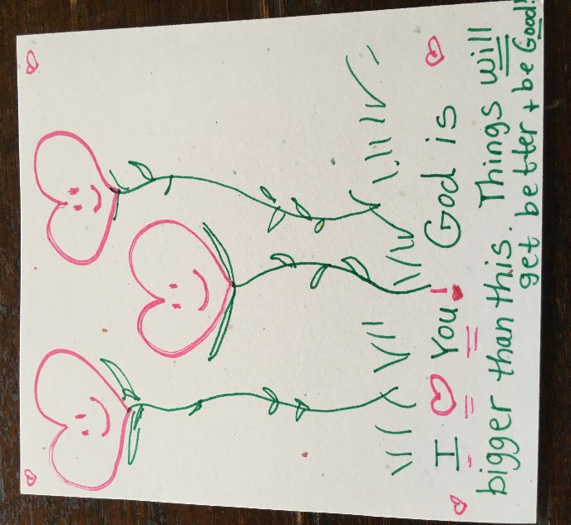

- I could have also written a reminder of God’s love or a Bible verse on this picture and kept it for myself. Either way brings some simple cheer in a mundane or down moment, and helps to stay focused on where God is in the story of the day.

- Listen: to the song “Whom Shall I Fear” by Chris Tomlin. The chorus says

I know who goes before me
I know who stands behind
The God of angel armies
Is always by my side

So, in closing this chapter’s study, remember that God is present in your story. Take time to notice the good things he always provides, and you will see him more and more through both the good and the bad.

